# Chapter 3: Contrail DPDK vRouter

## Contrail Software Stack

This picture shows the high-level description of the contrail architecture.

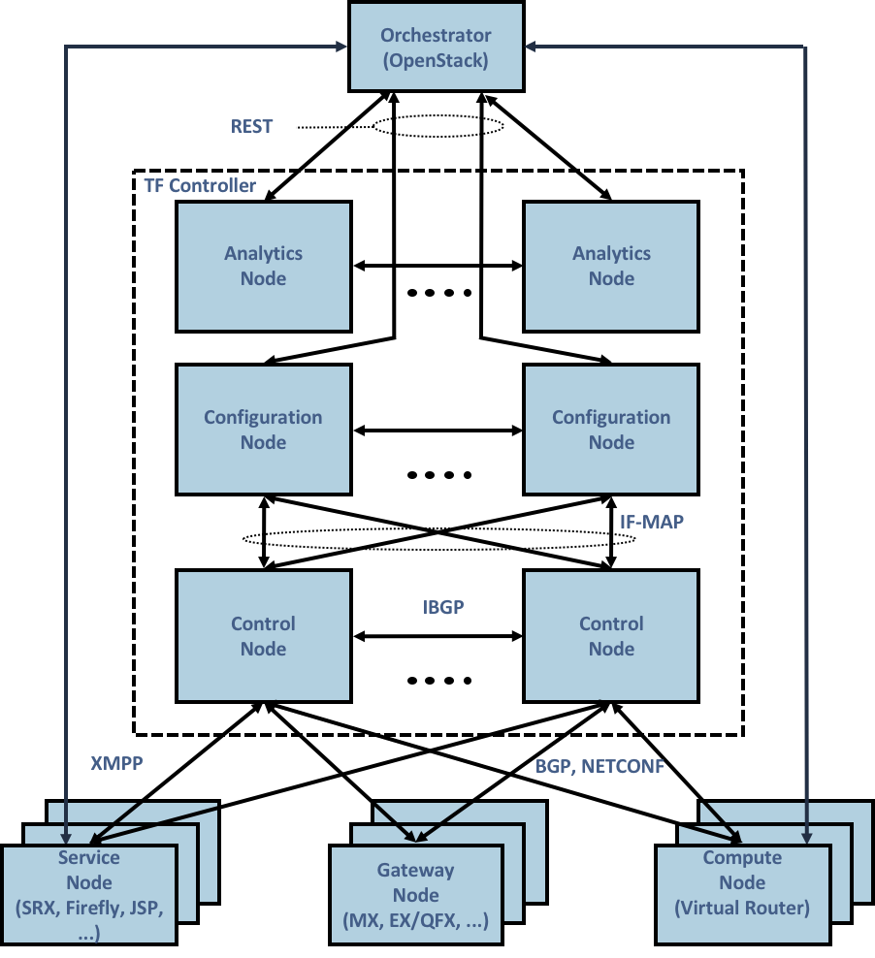

At the top, there is an orchestrator which can be Openstack or Kubernetes. Below that, there are controller components like control node, config node and analytics node. At the bottom right is the compute node. The compute nodes are general purpose x86 servers which will be the main focus of this chapter.

## Contrail compute node

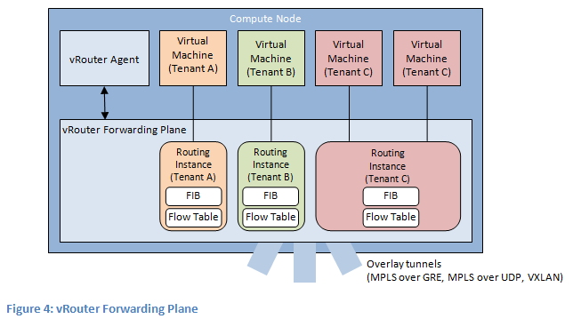

This picture shows a detailed view of the compute node. It is the place where vRouter runs. It is the most important component of contrail dataplane. We can see some workloads running. The workloads can be either virtual machines or container. These workloads have their interfaces plumbed into the vRouter.

At a high level, vRouter switches the packets between the VM interfaces and physical interfaces after doing some encapsulations or decapsulations. Each of this VMs have a corresponding forwarding state or routing instance inside vRouter which it uses to switch the packets. The physical interface can be single or bonded mode.

This vRouter itself can be running inside kernel or as a userspace DPDK process. There is a vRouter agent process also running in user space. The agent has a connection to the control node using a XMPP channel which is used to download configurations and forwarding information. The main job of the agent is to program this forwarding state to vRouter.

## vRouter and it’s interfaces

The picture below describes the vRouter and its interfaces to the outside world. It has interfaces to each of the workloads (VM1, VM2.. VMn) that it manages. These are typically tap interfaces.

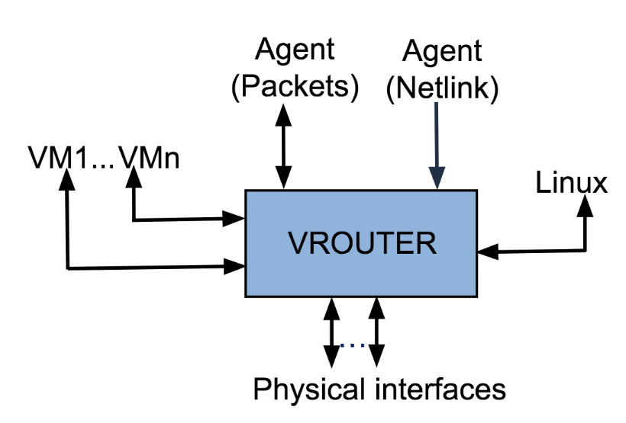

To send packets to other physical servers or switches, it uses the physical interfaces. They can be single or bonded NIC. vRouter is only interested in overlay packets or the packets to/from the workloads. For other packets, it uses the linux interface to send them to the host operating system.

This linux interface is called vhost0. It also has netlink interfaces toward the vRouter agent to download the forwarding state and also to send/receive some exception packets. The name of the later is called pkt0 interface.

Local control plane (agent)

Openstack integration (port add)

## vRouter architecture

vRouter is the workhorse of the Contrail system. Each and every packet to and from the contrail cluster goes through vRouter. vRouter is highly performant, efficient and has the capability to process millions of packets per second. It is multi-threaded, multi-cored and multi-queued to achieve maximum parallelism and exploit the x86 hardware to the maximum extent.

To support the rich and diverse features, vRouter has a sophisticated packet processing pipeline. The same pipeline can be stitched by the vRouter agent process from the simplest to the most complicated manner depending on the treatment which needs to be given to a packet. vRouter maintains multiple instances of forwarding bases and all the table accesses and updates use RCU (Read Copy Update) locks which is kind of lockless.

### vRouter packet processing Pipeline

The vRouter packet processing pipeline is described in the picture below.

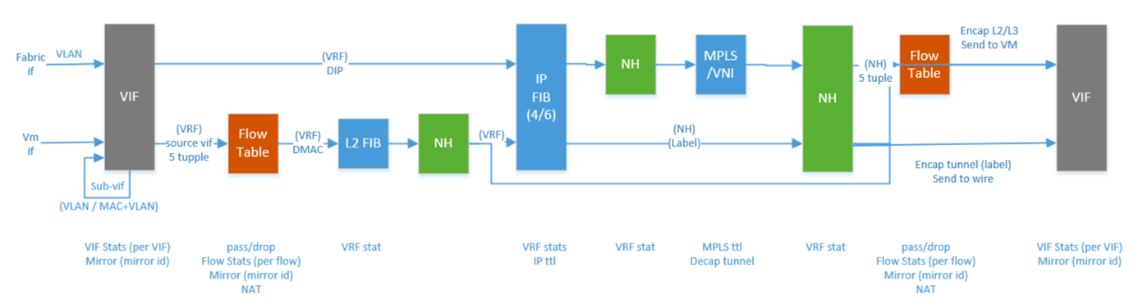

There are various tables and engines in action in this pipeline. Some of the important tables in this pipeline are flow table, route table, NH table and the MPLS/VXLAN table. The vRouter agent programs these tables based on the forwarding state it receives from the control node and also based on its own internal processing. Each packet, depending on which interfaces it is coming from, is subjected to the desired processing.

At a high level, all packets enter from an interface called ‘vif’. The vifs are nothing but one of the vRouter interfaces that we described previously. Depending upon the configuration of that interface, it enters different pipeline stages, doing lookups in different tables and based on what actions are defined in each stage, the packets are modified accordingly.

At the end of the processing, it is sent to another vRouter interface or vif after encapsulation or decapsulation. This is a fairly generic pipeline and the agent stitches this based on the rich feature set that the contrail cluster is configured.

### vRouter dataplanes overview

Contrail supports three kinds of vRouter dataplanes:

#### Linux Kernel

In this mode, vRouter dataplane runs as a kernel module (vrouter.ko) inside the linux operating system. This is the default installation mode when configuring a compute node. vRouter gets packets from any interface using the *netdev_rx_handler_register()* API provided by linux kernel. It makes use of the linux TCP/IP stack’s NAPI (new API) mechanism to do so. It is interrupt based and is prone to large latencies.



The packets are sent to the VMs using the VirtIO vhost-net mechanism of the linux kernel. vRouter will only take care of dataplane forwarding. With respect to the packet processing performance, the tuning has to be done at Linux Operating System level.

#### DPDK

In this mode, vRouter dataplane runs as a user space application that is linked to the DPDK library. This is a performant version of vRouter that is commonly used by telcos, where the VNFs themselves are DPDK based applications. The performance of vRouter in this mode is more than 10 times higher than the kernel mode. The physical interface is used by DPDK’s poll mode drivers instead of linux kernel’s interrupt-based drivers.



Consequently, the vRouter application (and not linux kernel) needs to be heavily tuned to get the best packet processing performance.

In this chapter we’ll mainly focus on the DPDK vRouter.

#### SmartNIC

In this mode, the Contrail vRouter dataplane runs inside the SmartNIC itself. This means, host resources are not involved in packet processing. It saves the CPU resources that will be used by vRouter for packet processing.



Currently, contrail offers solutions with Smart NICs from Netronome and Mellanox. At the time of writing of this book, a solution based out of Intel PAC N3000 smart NIC support was being worked on.

<<< The below section looks out of flow >>>

### vRouter dataplane deep dive

#### Kernel vRouter dataplane

vRouter agent has two interfaces:

* vhost0: used to communicated with Contrail controllers and to exchange XMPP packets, this interface connect to vif0/1 in vRouter dataplane
* pkt0: used to communicate with the vRouter dataplane. The vRouter dataplane is using this interface to forward to vRouter agent a copy of any incoming packet for which no processing and forwarding rules is known. This interface connect to vif0/2 in vRouter dataplane



Only a single physical interface can be connected onto the vRouter. This interface is connected to vif0/0 vRouter interface. For redundancy purpose, we are generally connecting a Linux “bond” interface to vif0/0, and the “bond” interface typically has two member interfaces in it. Typical bond interface mode is mode 4 (LACP) but also you can find mode 1 (active/standby).

Virtual Machine Network interfaces (VNIC) are VirtIO interfaces. Each VNIC is connected to a distinct vif interface on the vRouter dataplane (vif0/N, N is 3 and higher).

A specific Kernel Module is loaded by the vRouter dataplane. This specific Kernel module is allowing the vRouter to get a direct access to Linux TCP/IP stack.

In this architecture, an important part of the packet processing is performed by the Linux TCP/IP stack. NIC queues (either physical or virtual) are handled by Linux Operating system.

For each packet received by a NIC in a RX queue, an interrupt is generated and sent to the vRouter dapaplane in order to get the packet processed. Once a packet has been processed by the vRouter dataplane, it is sent into a TX queue. Then another interrupt is generated for each packet received into the TX queue in order to warn either a virtual machine a packet has been received on one of its virtual NIC, or to warn the compute operating system that a packet has to be sent to the underlay network.

Kernel mode vRouter packet processing is working in interrupt mode. This mode is generating lots of context switching between Linux TCP stack and vRouter application.

When the packet flow rate is low this is working well. But as soon as the network packets rate is rising the system is overwhelmed with the number of interrupts generated.

#### DPDK vRouter dataplane

vRouter DPDK interface numbering is the same as for Kernel mode.

But when DPDK is used, the vRouter dataplane is fully running in user space. There are no more vRouter dataplane piece of code running in kernel space. DPDK Poll Mode Drivers (PMD) are used to manage network interfaces configuration in user space. A (usually vfio or uio) is used to expose network interfaces registers into user space to make them reachable by DPDK PMD.

All NICs connected to the vRouter are moved from Linux kernel space to user space and therefore no more managed nor visible by the operating system. Consequently, it is the DPDK application - here the vRouter - that is fully processing the network packets. This includes packets polling, packets processing and packets forwarding. No more action is taken in charge by the operating system. All user packet processing steps are performed by the vRouter DPDK dataplane.



The nature of “polling mode” makes the vRouter DPDK dataplane processing packet forwarding much more efficiently as comparing with interrupt mode when packet rate is high. There are no more interruptions and context switching between Linux Kernel and vRouter dataplane application.

NOTE: When the network packet rate is low, this way of working could be less efficient than the regular Kernel mode. Indeed, for DPDK mode we are booking a set of CPU fully dedicated for packet processing purpose. If the network packets rate is too low, lots of CPU cycle are unused and wasted.

## DPDK vrouter dataplane internal architecture

### DPDK vRouter software architecture

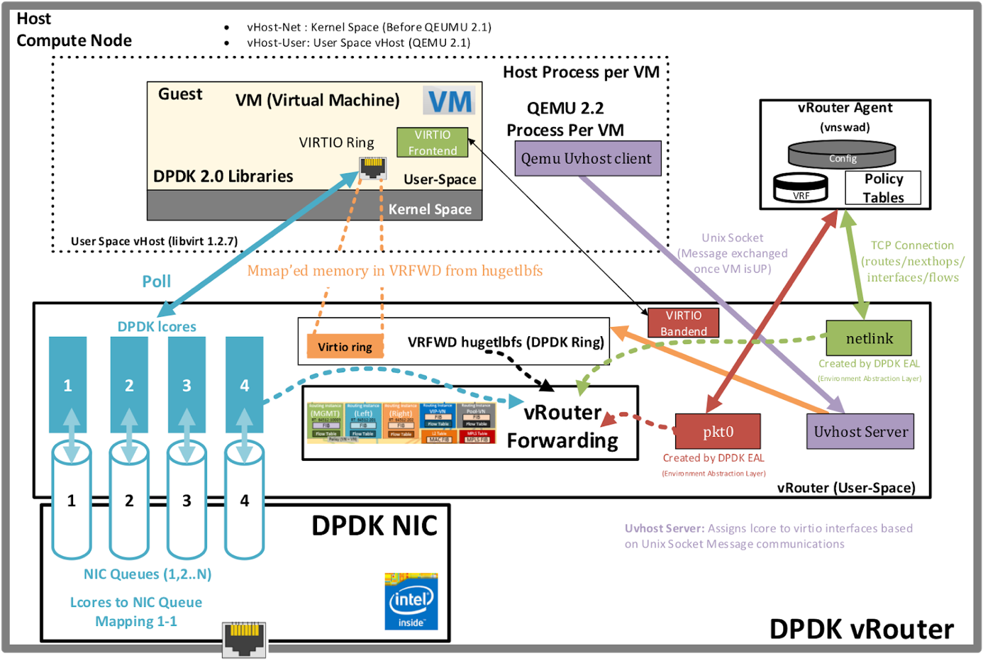

DPDK vRouter is a userspace application. It is comprised of multiple pthreads, also called lcores in DPDK terminology. Each pthread performs a specific functionality. The lcores are connected with one another by the help of DPDK queues and run in poll mode. They also poll different vRouter interfaces like - physical, VM and tap. The *main()* function is located in the file vrouter/dpdk/dpdk_vrouter.c.

<How about describe virtio Frontend – backend parameters exchange? as it is on the diagram, on one of presentations Kiran nicely described it. Kiran can you add it here?

The same for Uvhost client - server>

The entrypoint to the different pthreads is *vr_dpdk_lcore_launch()* in vrouter/dpdk/vr_dpdk_lcore.c

<< Explain fwd threads, service, control, pkt0, tapdev and other threads >>>

Polling and processing tasks are performed by Linux threads. These threads are automatically spawned by the vRouter with a well-defined CPU list. The vRouter is running as many as polling and processing threads as the number of polling and processing CPU allocated to the vRouter (defined in CPU_LIST DPDK vRouter variable).

They will be described into the following sections.

[root@a7s4 ~]# ps -T -p $(pidof contrail-vrouter-dpdk)

PID SPID TTY TIME CMD

3685 3685 ? 03:47:37 contrail-vroute

3685 3800 ? 00:04:32 eal-intr-thread

3685 3801 ? 00:00:00 rte_mp_handle

3685 3802 ? 04:55:48 lcore-slave-1

3685 3803 ? 00:00:02 lcore-slave-2

3685 3804 ? 00:00:11 lcore-slave-8

3685 3805 ? 00:04:12 lcore-slave-9

3685 3806 ? 6-16:39:37 lcore-slave-10

3685 3807 ? 6-16:40:48 lcore-slave-11

3685 3808 ? 6-16:35:35 lcore-slave-12

3685 3809 ? 6-16:37:52 lcore-slave-13

3685 3810 ? 6-16:34:48 lcore-slave-14

3685 3811 ? 6-16:36:19 lcore-slave-15

3685 3812 ? 6-16:44:21 lcore-slave-16

3685 3813 ? 6-16:43:43 lcore-slave-17

3685 5048 ? 00:00:00 lcore-slave-9

#### Virtio (vhost-user, qemu, mergeable buffers, gro, gso, mbuf chaining)

#### netlink (agent, pkt0, nh programming )

#### host (vhost0, tuntap, kni)

#### fabric (bond, pmd, offloads, lcore queues, nic queues)

#### Pipeline vs Run-to-completion model

Pipeline model is a model where a software is divided into multiple stages. Each stage completes part of the processing and hands it over to the next stage and so on. The way to handover is using a FIFO between the stages. These FIFOs are potential latency killers. But the tradeoff is that the architecture is more robust to ensure more load balancing and more cache friendly.

Run-to-completion model is a model where the software does not have multiple stages and it does the entire processing in a single context or single stage.

There are no FIFOs here ensuring that latency overheads are less. But this may not be very cache friendly, specifically I-cache. Also, more constraints on load balancing needs to be imposed.

Contrail vRouter uses a hybrid mode where it uses part pipeline and part run-to-completion there by ensuring good load balancing and also a reasonable latency. But is has a dependency on the FIFOs in the system.



### statistics

### vRouter communication paths

#### User packets (vif0/0, vif0/N)

User packets processing is consisting to forward network packets between user Virtual Machines located inside the Cloud infrastructure or between these machines and external networks.

In order to do so, each vRouter DPDK dataplane is built with:

* a vif0/0 network interface which is used to interconnect the vRouter with the physical network
* one to several Virtual NIC belonging to the virtual machines spawn onto the compute node. These virtual NIC are vif0/N on the vRouter (N > 2).



The main task of the vRouter consists to forward packets between vif0/0 and other vif 0/N. In order to do so; polling and processing tasks are pinned on vRouter dedicated CPU (polling and processing cores). These polling and processing tasks are reading or writing network packets from vif queues using DPDK functions. These network queues are DPDK rings build with DPDK poll mode driver on the physical NIC connected to vif0/0 or with virtio for virtual machines virtual NIC.

These polling and processing tasks are performed by lcore 10, lcore 11, lcore 12, lcore 13 and higher Linux threads.

#### agent to controller (XMPP & vhost0)

One other role of the vRouter DPDK dataplane is to provide the network connectivity between vRouter agent started locally on the compute node and the Contrail Control nodes.

Contrail vHost0 interface is the logical network interface used by the vRouter agent to send (or receive) XMPP to (from) the Contrail Control nodes.

vHost0 vRouter agent interface is connected on vif0/1 on the vRouter DPDK dataplane.



vRouter DPDK dataplane polling and processing cores are used to forward XMPP packets between vif0/1 (vRouter agent vhost0 listening interface) and vif0/0 (connecting to the underlay infrastructure on which Contrail Control nodes are plugged).

#### agent to dataplane (netlink, pkt0)

One last role of the vRouter DPDK dataplane is to provide a network connectivity channel with the vRouter agent. This network channel is used for two main purpose:

* DPDK setup (number of polling and processing cores, DPDK ring size, …) and vRouter dataplane configuration (add/remove virtual NICs to the vRouter)
* transfer network control information (IP routes, MAC and flow tables) from the vRouter agent to the vRouter dataplane

Two network channels are used:

* vif 0/2 is bound to pkt0 vRouter agent interface. This network connectivity is used to send a copy of any user incoming packet to the vRouter agent for which no network processing rules is known by the vRouter dataplane. Then the vRouter agent can make a decision (drop or forward) for this new incoming flow.
* Netlink Unix Socket is used by the vRouter agent to push network control information (IP routes, MAC and flow tables) to the vRouter dataplane. This information is pushed from agent in one of these modes:
  + in a proactive mode thanks to rules provided by Contrail Control nodes
  + in a reactive mode in response to a new incoming packet received on vRouter agent pkt0 interface



vRouter DPDK dataplane control and configuration task are handled by two kind of threads:

* DPDK control threads for DPDK setup
* vRouter Service threads for vRouter dataplane setup and vRouter control information processing

#### All in one picture

All different building blocks of Contrail DPDK vRouter are gathered in a single diagram shown below:



## Contrail DPDK vRouter user packet processing

### Packets polling and processing

During initialization of the NIC interface, vRouter configures it with the same number of queues as the number of forwarding cores it has. For example, if the vRouter has 5 forwarding cores, the number of Rx queues it configures to the NIC is 5.

A vif queue is made up of two DPDK rings:

* one RX ring: in which are stored packets received from a NIC to be processed by the vRouter
* one TX ring: in which are stored packets to be sent by the vRouter to a NIC



Packets stored in vif RX rings are polled by a forwarding lcore. There is a one-to-one mapping between forwarding cores and the NIC’s Rx queues. Then the polled packets are processed by a the same lcore or different one (depending on the configuration) and then pushed to a target vif’s TX ring. We’ll discuss this in details in later sections.



Each lcore10 and higher started by a DPDK vRouter is a polling a processing thread. They are running onto a single CPU listed defined by CPU_LIST variable. We will use interchangeably in the next sections the term **lcore** or **thread** to speak about a vRouter thread pinned to a single CPU.

### 

### Single Queue versus Multi-Queue NIC

NIC connected to vRouter (either physical or virtual) can be configured to several queues.

Each NIC queue is automatically pinned to a single vRouter polling and processing thread (lcore10 and higher). Consequently, when a NIC is configured with only a single Q, all incoming and outgoing packets are processed by a single vRouter polling and processing threads.

In order to avoid binding all single queue interfaces on the same polling and processing thread; each interface queue is pinned to a distinct vRouter lcore into a round robin manner when each interface is created. Single queue vif0/3 is automatically pinned to lcore 10, single queue vif0/4 is automatically pinned to lcore 11, and so on.

Hence the vRouter whole CPU power is automatically distributed among all the single queue interfaces. This distribution is automatically defined for each interface and is kept unchanged during all the interface life duration.

When a NIC is configured with several queues, each single queue is bound to a distinct polling and processing thread (lcore). Hence the vRouter whole CPU power is automatically distributed among all the queues of a each multi queue interface.

Even if there is no hard rule that prevent a user to configure a different number of queue on a NIC as the number of lcores (polling and processing threads) configured on the vRouter; the best scenario is to configure each multi queue NIC with a same number of queue as the number of configured polling and processing threads on the vRouter.



NOTE: We also have to take into consideration that currently the DPDK vRouter is unable to process correctly a multi queue NIC which is configured with more queues than the number of polling and processing threads configured on the vRouter.

### 

### 

## Supported scenarios

A contrail DPDK vRouter is able to collect DPDK virtual machines as well as Linux Kernel packet processing virtual machines. Likewise, a contrail Kernel vRouter is also able to collect both DPDK and non DPDK virtual machines.



But only two scenarios are really making sense:

* Kernel mode vRouter collecting Kernel mode virtual machines
* DPDK vRouter collecting DPDK virtual machines

In the Kernel scenario, both Virtual Machines and Contrail vRouter are working with a regular Linux TCP/IP stack using interrupt mode packet processing. They are both suffering of same limitation (packet processing does not scale due to interrupt mode) and the same advantages (it does not require to book lots of CPU for packet processing). So this scenario is the best to be used when the collected virtual machines are not expecting a high network connectivity performance.

In the DPDK scenario, both Virtual Machines and Contrail vRouter are working with a DPDK library using poll mode packet processing. They are both suffering of same limitation (poll mode requires to book some CPUs for packet processing) and the same advantages (it allows to reach line rate packet processing). This scenario is the best to be used when the collected virtual machines are requiring a high network connectivity performance. Typically, Virtual Network Functions (VNF).

Hybrid cases are unsuitable. When a Kernel mode Virtual Machine is plugged onto a Contrail DPDK vRouter, it impacts very badly the whole Contrail vRouter performance. Indeed Contrail DPDK vRouter has to emulate interrupt mode using KVM features in order to kick the Virtual machine. It takes lots of DPDK vRouter resources that are no more available to perform DPDK packet polling and processing. This is not only impacting the Kernel Mode VM but all the other DPDK ones.

A DPDK Virtual machine plugged onto a Contrail Kernel mode vRouter is also very inefficient. Even if the Virtual machine is able to process its network packets at a very high speed, Linux Kernel packet processing used by Kernel mode vRouter does not scale well. So, at the end lots of packets generated by a high speed VNF plugged on a Contrail Kernel mode vRouter could by lost.

This is why Contrail users have to be consistent and to plug DPDK Virtual machines onto DPDK dataplane vRouter and Kernel mode Virtual machines onto Kernel mode dataplane vRouter.

When an virtual infrastructure is made up of several kinds of virtual machines (both DPDK and not DPDK ones), placement strategy have to be defined in order to spawn DPDK VM onto computes fitted with Contrail DPDK vRouter and to spawn non DPDK VM onto computes fitted with Contrail Kernel mode vRouter.

## Backup content

Contrail vRouter DPDK dataplane is built with two software components:

* DPDK library
* vHost user VirtIO library

DPDK library is allowing to connect one physical NIC to the Contrail vRouter. This NIC is named vif0. This is the vRouter network interface toward the physical infrastructure (underlay network infrastructure). This library is also used to manage packet forwarding:

* between vRouter physical interface and virtual interfaces of the Virtual machines. This is the traffic pattern exchanged between local Virtual Machines and remote ones or external networks.
* between virtual interfaces of local Virtual machines. This is pure local virtual network traffic.

In addition to DPDK, a Linux user space device enabler is required in order for the DPDK vRouter to be able to configure physical NIC from user space. VFIO or UIO can be used with Contrail vRouter.

vHost user VirtIO library is allowing to interconnect the virtual NICs of virtual machines to the vRouter using vHost user protocol.

NOTE: vRouter code is present in this github repo - <https://github.com/tungstenfabric/tf-vrouter> - The DPDK specific code is present in vrouter/dpdk directory